Threshold Salon Preparation Sheet

Threshold Salon List:
- How often do you do it?
- What is the date today?
- Find the way
- I am sick
- What do you want to be?
- Which one is bigger?
- Seasons and vacations
- Experiences
- My favorites
- Joe and the Poor Man
- Cartoon Stories
- What if….
- Potluck
- I feel happy
- My new job
- How much is it?
- The Party
- The five senses
- Right On Time
- What’s your hobby
- Small talk
- Making request
- Like it or not
- Getting around the city.
- Making plans
- Talking about me
- My pet
- Fast and Slow
- Friendship
- My Hometown
- I'm Hungry
- How Long and How Far
- To be or not to be
- In My House

THS1. How often do you do it?

Related Vocabulary:
Monday, Tuesday, Wednesday, Thursday, Friday, Saturday, Sunday
Always, usually, often, sometimes, seldom, never
Once, twice, three times,
Once a day / a week / a month / a year,
Every two days / two weeks / two months / two years
Twice a day / a week / a month / a year

Important Sentences:
What do you usually do in the morning?
How often do you do it?

THS2. What’s the date today?

Related Vocabulary:
January, February, March, April, May, June, July, August, September, October, November, December
First, second, third,
Festival, New Year’s Day, Valentines’ Day, Women’s Day, Fools’ Day, The Labour Day, The Children’s Day, The national Day, Halloween, Thanksgiving Day, Christmas Eve, Christmas Day.
Season, spring, summer, autumn, fall, winter

Important Sentences:
Which month is it now?
What month comes after January?
What is the date today?
Today is January, the 1st.
When is your birthday?
My birthday is on December, the 20th.
What season is it now?
It is summer.
My birthday is in winter.

THS3. Find the Way

Related Vocabulary:
near, in, on, under, between, behind, opposite, across from, in front of, left of, right of
right, left, go straight, turn, the first right, the second right
north, south, east, west, northeast, northwest, southeast, southwest
sit, stand, plan

Important Sentences:
Where are you sitting?
I am sitting at the desk.
Where is the book?
The book is under the sofa.
How can I get to your house from the station?
Go straight up the road, turn left at the corner, go straight and my house is on your left.

THS4. I am sick.

Related Vocabulary:
head, eye, ear, nose, throat, mouth, tooth, neck, stomach, arm, hand, finger, leg, foot, back,
headache, earache, sore throat, cold, toothache, stomach ache, broken arm, backache, fever, cut, cough, cough syrup, aspirin, pill, capsule, teaspoon,
because, so,

Important Sentences:
How are you?
I’m sick.
What’s wrong with you? / What’s the matter?
I got a cold.
You need to see a doctor.
You need to take some medicine.
Take two pills after meals three times a day

THS5. What do you want to be?

Related Vocabulary:
like to do, want to do, want to be, in the future
saleswoman, businessman, lawyer, doctor, baker, florist and other jobs.

Important Sentences:
What does he like to do?
He likes to make models.

What do you want to do?
I want to go to the moon.

What do you want to be?
I want to be an astronaut.

What does he want to be?
He wants to be an engineer. He doesn’t want to be a lawyer.

THS6. Which one is bigger?

Related Vocabulary:
fat-fatter-fattest, thin, tall, short, new, old, long, ugly
elephant, cheetah, gazelle, greyhound, jackrabbit, polar bear,
city, country, Seoul, New York, Korea, the Yangtze River, the Amazon River,

Important Sentences:
Which one is bigger, the elephant or mouse?
The elephant is bigger.

Is the Yangtze River longer than the Amazon River?
Yes, it is. / No, it isn’t.

Who is the tallest ?
Jim-bob is.

THS7. Seasons and vacations

Related Vocabulary:
Seasons, spring, summer, autumn(fall), winter
To go skiing, to go rowing, to fly a kite, to go camping, etc.
Last…, this…,next…

Important Sentences:
There are four seasons in a year.
Which season do you like best?
I like summer best because I like swimming.

What did she do last summer?
Last summer she went fishing.

What is she going to do next summer?
Next summer she’s going to go camping.

What is Tom going to do next week?
He’s going to go camping.

THS8. Experiences

Related Vocabulary:
play the piano, play golf, dive, ski, etc.
be- been, do- done, fly-flown, etc.

Important Sentences:
How old were you when you learned to ride a bike?
I was five when I learned how to ride a bike.

Has your brother ever been to France? No, he hasn’t.
Have you ever driven a taxi? Yes, I have.

How long has he been a teacher?
He has been a teacher for six years / since 2001.

THS9. My favorites

Related Vocabulary:
apple, banana, orange, pear, peach, lemon, watermelon, grapes, mango, pineapple, cherries, strawberry, radish, spinach, Chinese cabbage, cauliflower, garlic, carrot, tomato, cucumber, mushroom, onion, broccoli, eggplant

Important Sentences:
What’s your favourite fruit / dish…?
My favorite fruit is pineapple because it tastes sweet.
My favorite dish is toasted chicken because it smells savory.
My favorite music is the Beatles because it sounds wonderful.

THS10 – Joe and the Poor Man

Find the meanings of these words:
Beggar Gym Spanish Coin Banknote Play cards Smoke

THS11 – Cartoon Stories
No preparation

THS12 – What If …
Answer the following questions before you come to class:

- What will you do if it rains tomorrow?
- What will you do if you feel sick?
- What will happen if you drop your phone?
- What will happen if you eat KFC every day?
- What will happen if you drive too fast?

THS13. Topic: Potluck

Related Vocabulary:
bring, different, fun, interesting, make , potluck dinner, special

Important Sentences:
What do you like to eat for dinner?

What can I do for you?
Can I have a menu? / bill?
What’s your special today?
I would like to have …

THS14. Topic: I Feel Happy

Related Vocabulary:
happy sad angry tired bad
upset afraid good excited sleepy
glad scared unhappy confused bored
worried calm

Important Sentences:
"How do you feel when ...?"
"Do you feel ... when...?"
"When it's ... I am ..."

THS15. Topic: My New Job

Related Vocabulary:
chef, dentist, doctor, farmer, unemployed, hairdresser, lawyer, painter, retired,
secretary, singer, student, teacher, gym instructor, waiter

Important Sentences:
Who is she/ he? What does he/she do? What does a mail carrier usually do?

THS16. Topic: How Much Is It?

Related Vocabulary:
more, less, the most, the least

Important Sentences:
How much is…
How often do you…..

Sandwiches
chicken& onion
Cheeseburger
triple decker
Drinks
Coke
Pepsi
Tea
Hot water
Coffee
Appetizers
Onion rings
Squid rings
Mini burgers (4)
Ribs
chicken wings
Salad
Soup

Entrées
spaghetti
seafood noodle
steak
Desserts
waffles
toppings -whipping cream
blueberry pie

THS17. Topic: The Party

Important Sentences:
What are you doing on (day/date)?
Would you like to. . .?
How about. . .?
Do you want to. . .with me?
I'd like to invite you to. . .

THS18. Topic: The Five Senses

Related Vocabulary:
5 senses：
see, hear, touch, taste, smell

lick, listen, watch, hear, point, sniff, chew, blink, stroke, smell , sniff, chew, blink
stroke, smell

Important Sentences:
What’s your favorite smell?
What’s your favorite taste?
Which sense is most important to you? Why?
If you had to lose one of your senses,
Which one would you choose? Why?

THS19. Topic: Right On Time

Related Vocabulary:
Windows
Stairs
Dictionary
Whiteboard
Centimeters
Grams
Kilograms
Meters
Cousin

THS20. Topic: What’s Your Hobby?

Important Sentences:
What do you like doing?
What sort of hobbies do you have?
I'm interested in (+ noun / gerund)
I'm into (+ noun / gerund)
I enjoy (+ noun / gerund)

THS21. Topic: Small Talk

Related Vocabulary:
Your friend A movie Pets Music A book On the Internet
Sports Your job Place to go Superstar Video game
Keeping healthy Your favorite food English class The Weather
Holiday

Important Sentences:
How long have you been with the company?
What’s your job?
What do you do?

THS22. Topic: Making Request

Related Vocabulary:
a pen a ruler a piece of paper your coat a pencil sharpener some paper
Your shoes an eraser a dictionary a red pen some money
your Laptop Computer a students’ book a stapler your phone
a notebook a hole punch your new car a file some glue your bag
some tape your watch your mobile phone

Important Sentences:
Can/Could you please…
Can you switch on the light?
Can you answer the telephone?
Can you open the door?

Can I borrow…?

THS23. Topic: Like It or Not

Related Vocabulary:
love, enjoy, like, dislike, hate

Important Sentences:
What do you like to do?

THS24. Topic: Getting Around The City

Related Vocabulary:
School the grocery store your friend’s house

Important Sentences:
How do you get to…….?
I go by……..

THS25. Topic: Making Plans

Related Vocabulary:

Tomorrow | Tomorrow I will have English Class.
Day after tomorrow | Today is Saturday, the Day after tomorrow is Monday.
Weekend | I will have the Weekend (Saturday &Sunday) to get some rest.
Weekday | Weekday= Monday to Friday  I have class during the weekdays.
Piano | I can play the Piano
Run | I run every weekday and rest on the weekend.
Badminton | Badminton is a poplular sport in China.
Sing | I sing in the shower.

Important Sentences:
List what you will do on Saturday.

I will ____ _______ on Saturday

I will go run on Saturday.

I will play piano

THS26. Topic: Talking about me

Related Vocabulary:
Yesterday | Today is Saturday, yesterday (Friday) I went to school.
Breakfast | I eat eggs for breakfast.
People | There are five people in my English class.
Age | I learn to read at an early age.  At what age did you learn to read? At age 5.
Sport | What sport do you play? I play badminton.
Music | Do you like to listen to music? Yes, I like pop music.
Parents | My parents (Mother & Father) cook lunch for me.

Important Sentences:
Me too or Me neither

The best sport is…………………

I listen to music when……………

THS27. Topic: My Pet

Related Vocabulary:
Pet | Do you have a pet? Yes, I do. I have a dog.
Advantages | There are many advantages of having a dog.
Disadvantages | Disadvantage of having a dog is that it barks.

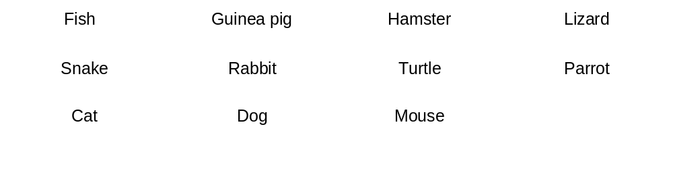 Important Sentences:

I have/ I don’t have

I have a dog, but I don’t have a cat.

THS28. Topic: Fast and Slow

Related Vocabulary:
elephant; giraffe; giant turtle; falcon; spider; snake;
chicken; garden snail; human; cheetah; ostrich; greyhound.

Important Sentences:
I agree/ I disagree
In my opinion
I think
A._______ is faster than a__________.
A._______is slower than a _________.

A Greyhound dog is faster than a turtle.
A Turtle is slower than a Chicken.

THS29. Topic: Friendship

Related Vocabulary:
angry | I am angry that the store closed early.
favorite | My favorite food is pizza.
finds | If he finds his money.
homework | I have lots of homework from school.
jokes | My friend likes to tell jokes.
kind | What kind of drink do you want.
lends | He lends money to his friends.
lies | He does not always tell the truth. He sometimes lies.
problems | I have many problems with my computer.
shares | He shares his lunch with another student.

Important Sentences:
Who is this?

This is my mother

Who is that?

That is my friend

THS30. Topic: My hometown
Nightlife | Shanghai has very good nightlife. People are out late.
Wildlife | The jungle has lots of wildlife.
Hometown | My hometown is in South China
Capital | The capital of France is Paris.
Fantastic | Wow! You did a fantastic job!
Negative | The person never says anything nice, they are so negative.
Transportation | Taxi is the best transportation in New York.
Interesting | The movie was interesting. I really enjoyed it.
Delicious | I eat delicious food during the Spring Festival.
Neighbors | Our Neighbors talk very loud. I can hear them from my house.
Nature | When I go camping, I enjoy nature.
Population | The population of China is growing.

Important Sentences:

- Do you like your hometown? Why?
- What makes your hometown interesting?
- How many people live in your hometown? What is the population?

THS31. Topic: I’m Hungry

Related Vocabulary:
Apple-Banana-Fish-Eggs-Bread-Milk-Corn-Cheese-Pepper-Rice-Carrots-Grapes

For this class, it is important to know type of food fits on a food chart.

Meat vegetables fruit dairy sweets

Beef Carrots Apples Milk Chocolate

Important Sentences:
Do we need……

It’s ______. I’m so hungry

Me too, lets have__________.

THS32. Topic: How Long and How Far

We use how far to talk about distance.
We use how long to talk about the amount of time something takes.

Important Sentences:
How far is __________.
How long is _________.

How far do you usually walk?
How long did you wait?
How far is it from _______ to ________.
It is __________ kilometers.
Remember, when you make a question with a verb other than the be verb, you need to use an auxiliary verb (do/did, have/had, will, are/is, etc.). For example:

How far do you usually walk? I walk 5 kilometers. (Present Simple)
How long did you wait? I waited 30 minutes. (Past Simple)

THS33. Topic: To be or not to be
Vocabulary

Snowing | It’s only September and it is snowing in Beijing.
Winter | I will go to the ice festival this Winter.
Cold | It is a very cold day today.
Tennis | Do you like to play tennis in your free time?
Sunny | Today is a nice sunny day! Let’s go to the park.

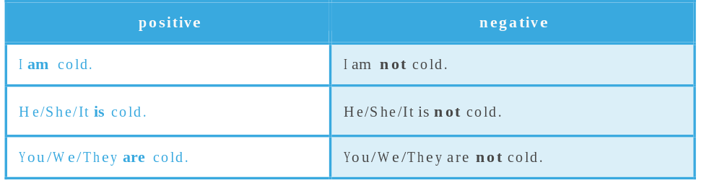

THS34. Topic: In my House

Related Vocabulary:
Dishes | After dinner, we washed our dirty dishes.
Washed | We washed our clothes.
Refrigerator | The refrigerator is new.
Garden | We picked vegetables from our garden.
Shower | I always take a shower at night.
Toys | The child played with their toys.
Cook | I will cook dinner for my child.

Important Sentences:
How Much
How Many

I have an oven in my kitchen.
I have a T.V. in my living room.

Five things you have in the kitchen

1._____ 2. _____. 3_____.4. _____ 5. _____

Five things you have in the bathroom

1._____ 2. _____. 3_____.4. _____ 5. _____

Five things you do in the living room

1._____ 2. _____. 3_____.4. _____ 5. _____

Five things you can see from the balcony

1._____ 2. _____. 3_____.4. _____ 5. _____

